Welcome to the West Royalty’s On-Line Lunch Ordering System!
Parent Instructions

Getting Started

To access the site, please go to the school hot lunch web site: https://westroyalty.hotlunches.net.
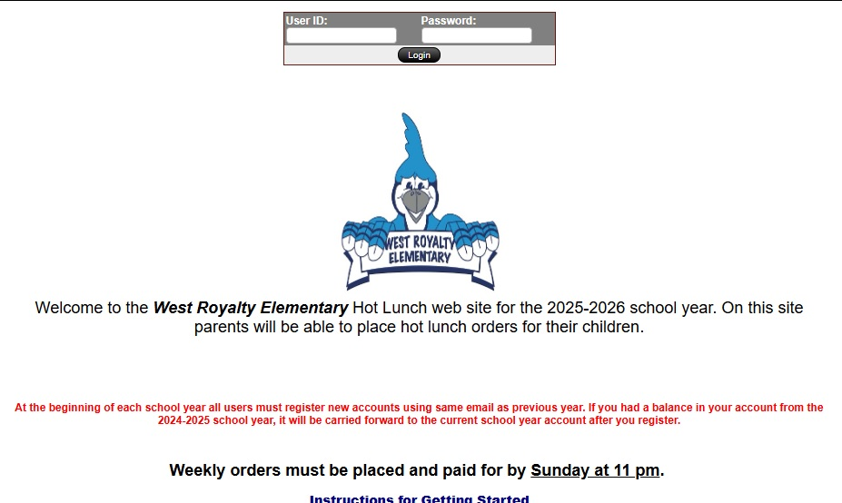

To use the system, you will be required to register and provide your name and email address. This site has an SSL Certificate to provide full security of your personal information and only the information needed to manage the lunch program is required.

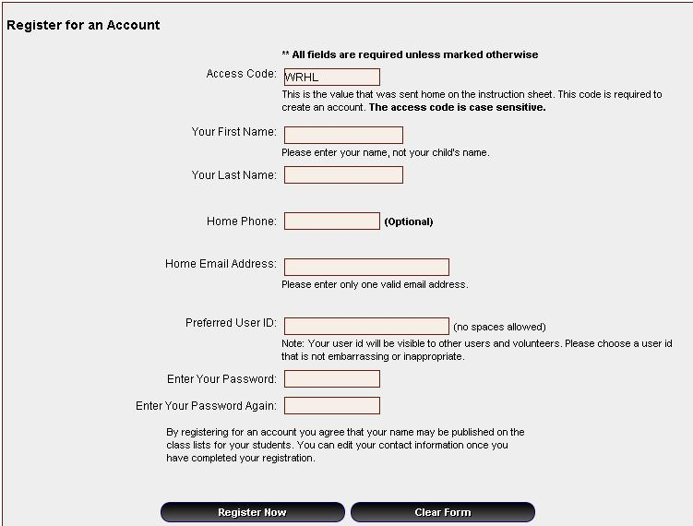
To register for an account, click on the “Click Here to Register” tab on the main menu bar. This will take you to the registration form to create an account for your family. Each family will have one account.

Enter WRHL as the School Access Code

Provide other information as required to complete your registration, and then click on “Register Now”.

You are now registered and ready to use the system. The next time you want to access the system, simply login with your email address and password.

For families who have difficulty gaining access to a computer please contact School Administration.

MANAGING STUDENTS

Once you have logged into the system you will be at the “Welcome Screen”. This is the first screen you will see each time you login and from here you can quickly access the major sections of the system.

The first step is to add your students to the system so that orders can be placed for them. To add your children to the system click on the “Students” button to access the student management screen.


Type their First and Last Name and select their class and teacher from the dropdown menu, then click on “Insert”.

If your child lives in two homes, both parents can register and place orders by appending Mom or Dad to the child’s last name, as the system does not accept the same student name twice.

Placing Lunch Orders

Once your students have been added to the system you can immediately place lunch orders for each student.

To see the name(s) of your child(ren), click on the “HOME” tab and then on “Students”.

Below your child’s name, you will see the Schedules currently available to order.

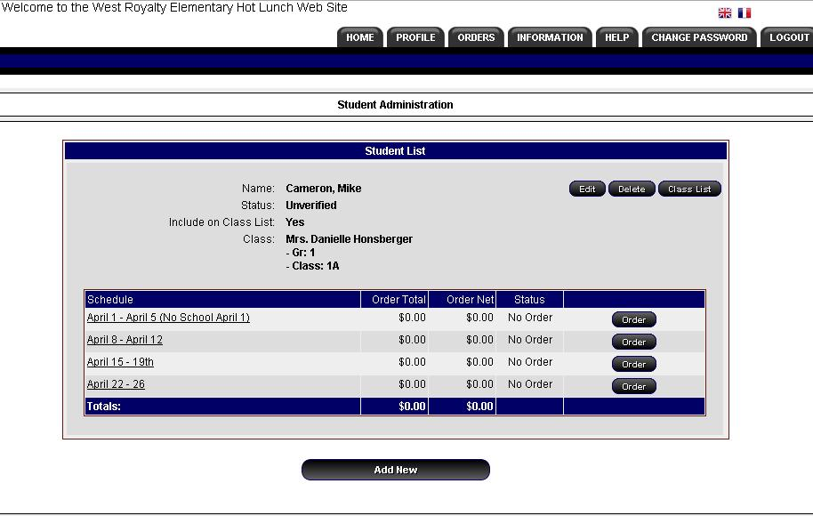

To place your order, click on the “Order” button beside the Schedule of interest.

By clicking on the “Order” button you will be able to place or edit an order for the student. The order form will indicate the date range during which orders will be accepted.

Lunch Order Form

The lunch order form is organized by dates and each menu item available on each date is listed with the price and a box for you to enter the quantity you wish to order. When you enter a quantity the line price is automatically calculated and the total for the date is displayed at the bottom of each lunch date.
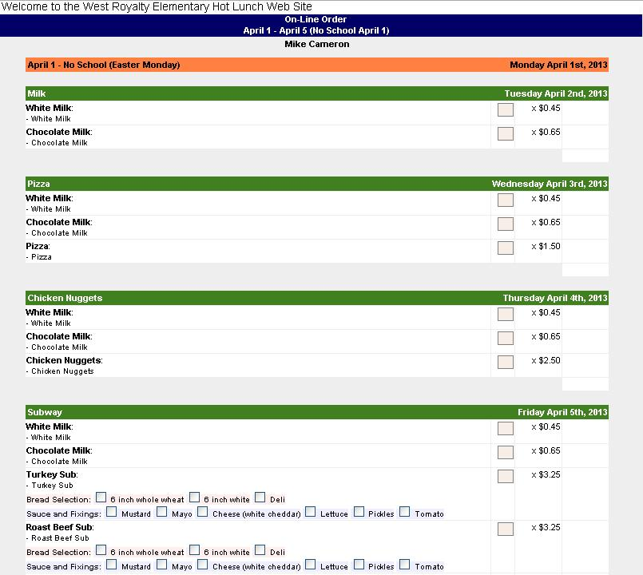

.

Enter the quantity or check the items you would like to order, and once done, click on “Update Order and Proceed” at the bottom of the form.

Lunch Order Payment

Once you have completed the order and clicked on the “Update Lunch Order” button you will be taken to a screen where all the orders for all of the current lunch schedules are summarized.

The Order Balance Owing will be displayed at the bottom of the summary.

Payment should be made only after all student orders have been completed for all desired schedules.

After placing all your orders, click Place Order & Proceed which will bring you to Bambora payment. Enter credit card click Pay.

All payments must be received at the time of ordering. If the payment is not made at the time of ordering, the order will not be processed.
Your child’s order and payment must be made by 11pm on Sunday.

Email Notifications and Profile

The system will send you a confirmation email after you have placed an order.

It will also send you a weekly reminder with what you ordered for the upcoming week.

If you need to change your email address or want to change your password, please move your mouse over the “Profile” tab and once the menu drops down click on “Edit Account Profile”.

Additional Information and Help

Please follow the instructions in this guide and read the Frequently Asked Questions document.

If you need help registering or using the online ordering system, please call the School.

If you are logged in to the system, you may select “Support Request” under the “Help” tab and send your question from there.

